[](http://vk.com/photo-57880788_409505777)

[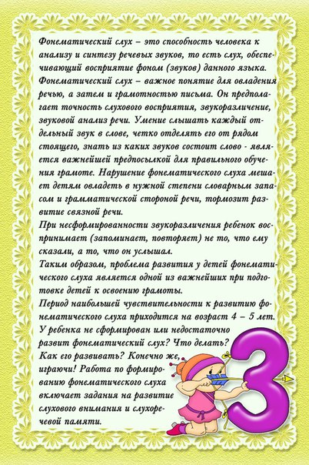](http://vk.com/photo-57880788_409505787)

[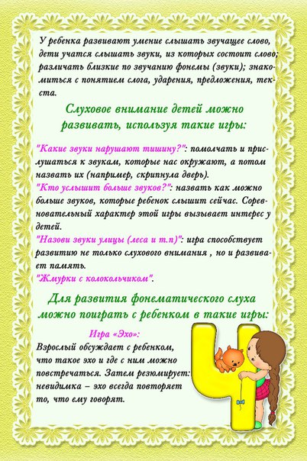](http://vk.com/photo-57880788_409505792)

[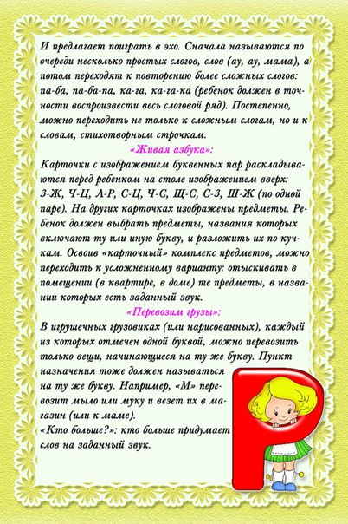](http://vk.com/photo-57880788_409505794)

[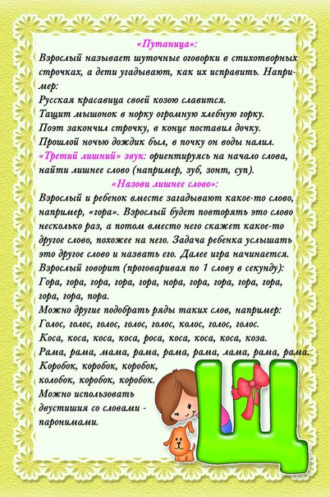](http://vk.com/photo-57880788_409505796)

[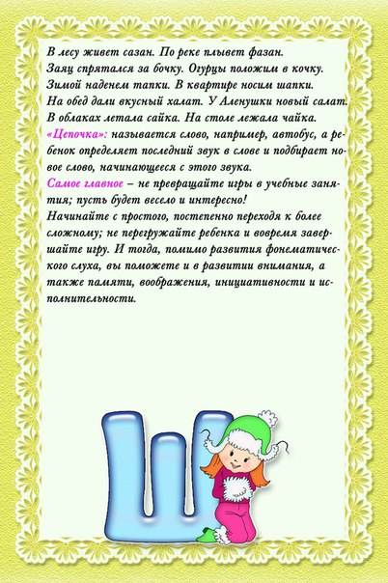](http://vk.com/photo-57880788_409505801)